**Anjuman-I-Islam’s**

M.H. Saboo Siddik Polytechnic

8, M.H. Saboo Siddik Polytechnic Road, Mumbai, 400008



SECOND YEAR DIPLOMA IN COMPUTER ENGINEERING

(2022-23)

PROJECT REPORT ON

**LRU PAGE REPLACEMENT ALGORITHM**

By

210451- Abdurrahman Qureshi

210453- Ansari Saad

210460- Arya More

210463- Adnan Kazi

UNDER THE GUIDANCE OF

**Mrs. Kausar Akumalla**



Maharashtra State Board of Technical Education (MS-BTE)



**MAHARASHTRA STATE**

**BOARD OF TECHNICAL EDUCATION**

**Certificate**

This is to certify that Mr. Abdurrahman Qureshi Roll no. 210451 of fourth semester of Diploma in Computer Engineering of institute M.H. Saboo Siddik Polytechnic (code: 0002) has completed micro project satisfactorily in the subject: OSY (22516) for the academic year 2022-23 as prescribed in the curriculum.

Place: Byculla, Mumbai Enrolment no:2100020112

Date: ______________ Exam seat no:

Signature Signature Signature

Project guide H. O. D Principal

SEAL OF

INSTITUTE



**MAHARASHTRA STATE**

**BOARD OF TECHNICAL EDUCATION**

**Certificate**

This is to certify that Mr. Ansari Saad Roll no. 210453 of fourth semester of Diploma in Computer Engineering of institute M.H. Saboo Siddik Polytechnic (code: 0002) has completed micro project satisfactorily in the subject: OSY (22516) for the academic year 2022-23 as prescribed in the curriculum.

Place: Byculla, Mumbai Enrolment no:2100020102

Date: ______________ Exam seat no:

Signature Signature Signature

Project guide H. O. D Principal

SEAL OF

INSTITUTE



**MAHARASHTRA STATE**

**BOARD OF TECHNICAL EDUCATION**

**Certificate**

This is to certify that Mr. Arya More Roll no. 210460 of fourth semester of Diploma in Computer Engineering of institute M.H. Saboo Siddik Polytechnic (code: 0002) has completed micro project satisfactorily in the subject: OSY (22516) for the academic year 2022-23 as prescribed in the curriculum.

Place: Byculla, Mumbai Enrolment no:2100020097

Date: ______________ Exam seat no:

Signature Signature Signature

Project guide H. O. D Principal

SEAL OF

INSTITUTE



**MAHARASHTRA STATE**

**BOARD OF TECHNICAL EDUCATION**

**Certificate**

This is to certify that Mr. Adnan Kazi Roll no. 210463 of fourth semester of Diploma in Computer Engineering of institute M.H. Saboo Siddik Polytechnic (code: 0002) has completed micro project satisfactorily in the subject: OSY (22516) for the academic year 2022-23 as prescribed in the curriculum.

Place: Byculla, Mumbai Enrolment no:2100020117

Date: ______________ Exam seat no:

Signature Signature Signature

Project guide H. O. D Principal

SEAL OF

INSTITUTE

**Acknowledgment**

We wish to express our profound gratitude to our guide Mrs. Kausar Akumalla Ma’am who guided us endlessly in the framing and completion of the micro project. She guided us on all the main points in that micro project. We are indebted to his/her constant encouragement, cooperation, and help. It was his/her enthusiastic support that helped us in overcoming various obstacles in the micro-project. We are also thankful to our Principal, HOD, faculty members and classmates of Computer Engineering department for extending their support and motivation in the completion of this micro-project.

Names of Team Members with Roll Nos.

1. Abdurrahman Qureshi – 210451
2. Ansari Saad – 210453
3. Arya More – 210460
4. Adnan Kazi – 210463

***Annexure-I***

#### IV. Action Plan

|  |  |  |  |  |
| --- | --- | --- | --- | --- |
| **Weeks** | **Details of activity** | **Planned start date** | **Planned finish date** | **Name of responsible team members** |
| 1& 2 | Discussions & finalization of topics |  |  |  |
| 3 | Preparation of abstract |  |  |  |
| 4 | Literature review |  |  |  |
| 5 | Submission of Micro-Project proposal(Annexure -I) |  |  |  |
| 6 | Collection of information on given topic |  |  |  |
| 7 | Collection of all relevant contents |  |  |  |
| 8 | Discussion and submission of outline of the project |  |  |  |
| 9 | Analysis/execution of collected data/information and Preparation of prototypes/drawings/charts/graphs/ tables/models/circuits/programs etc. |  |  |  |
| 10 | Compilation of contents of project |  |  |  |
| 11 | Compilation of weekly progress report |  |  |  |
| 12 | Preparation of the project report (Annexure II) |  |  |  |
| 13 | Viva Voce / Delivery of presentation. |  |  |  |

#### V. Resources required

|  |  |  |  |  |
| --- | --- | --- | --- | --- |
| **Sr. no.** | **Name of resources** | **Specifications** | **Qty** | **Remarks** |
| 1. | Online | Learning resources and various websites | 5 sites |  |
| 2. | Desktop | Microsoft word, Tools with internet facility. | 1 for each |  |

Names of Team Members with Roll Nos.

1. 210451 Abdurrahman Qureshi

2. 210453 Saad Ansari

3. 210460 Arya More

4. 210463 Adnan Kazi

Approved by:

Sign of Faculty:

Name of faculty: Mrs. Kousar Akumalla

**IV. Literature Review**

Page replacement algorithms are categorized into three types:

* FIFO (First in First Out)
* LRU (Least Recently Used)
* OPTIMAL PAGE REPLACEMENT

1.FIFO: This is the simplest page replacement algorithm. In this algorithm, the operating system keeps track of all pages in the memory in a queue, the oldest page is in the front of the queue. When a page needs to be replaced page in the front of the queue is selected for removal.

2. OPTIMAL PAGE REPLACEMENT: In this algorithm, pages are replaced which would not be used for the longest duration of time in the future. Optimal page replacement is perfect, but not possible in practice as the operating system cannot know future requests. The use of Optimal Page replacement is to set up a benchmark so that other replacement algorithms can be analysed against it.

3. LEAST RECENTLY USED(LRU): The LRU stands for the Least Recently Used. It keeps track of page usage in the memory over a short period of time. It works on the concept that pages that have been highly used in the past are likely to be significantly used again in the future.

In an operating system that uses paging for memory management, a page replacement algorithm is needed to decide which page needs to be replaced when a new page comes in.

What is a Page fault?

A page fault happens when a running program accesses a memory page that is mapped into the virtual address space but not loaded in physical memory. Since actual physical memory is much smaller than virtual memory, page faults happen. In case of a page fault, Operating System might have to replace one of the existing pages with the newly needed page. Different page replacement algorithms suggest different ways to decide which page to replace. The target for all algorithms is to reduce the number of page faults.

**V. Actual Methodology Followed**

We were assigned with the micro project topic and time was assigned to us to complete the project in 11 weeks. All team members worked together in these 11 weeks together in order to complete this micro project. Data was collected according to our topic. Presentation was prepared, technical report was prepared and then we prepared ourselves to deliver the presentation.

**VI. Actual resources used**

|  |  |  |  |  |
| --- | --- | --- | --- | --- |
| **Sr. No.** | **Name of Resource/material** | **Specifications** | **Quantity** | **Remarks** |
| **1** | Computer Science Websites | www.geeksforgeeks.org, www.javapoint.com, www.guru99.com | 3 websites |  |
| 2 | Software | VMWare, UBUNTU  Terminal, FireFox | 1 |  |
| 3 | Websites | Geeksforgeeks, Browser  javapoint, github | 1 |  |

**VII. Outputs of Micro project**

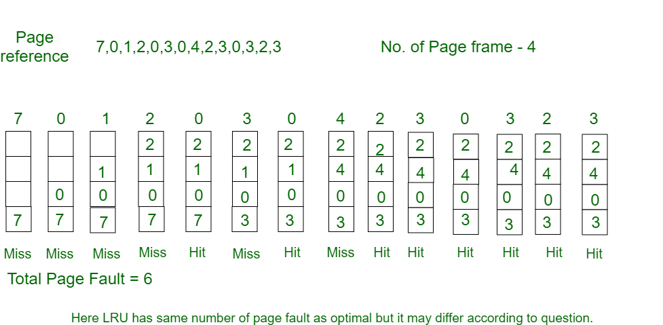**Example:**Consider the page reference string 7, 0, 1, 2, 0, 3, 0, 4, 2, 3, 0, 3, 2, 3 with 4 page frames. Find number of page faults.

Initially, all slots are empty, so when 7 0 1 2 are allocated to the empty slots —>**4 Page faults**   
0 is already there so —> **0 Page fault.** when 3 came it will take the place of 7 because it is least recently used —>**1 Page fault**   
0 is already in memory so —>**0 Page fault**.   
4 will takes place of 1 —>**1 Page Fault**   
Now for the further page reference string —>**0 Page fault** because they are already available in the memory.

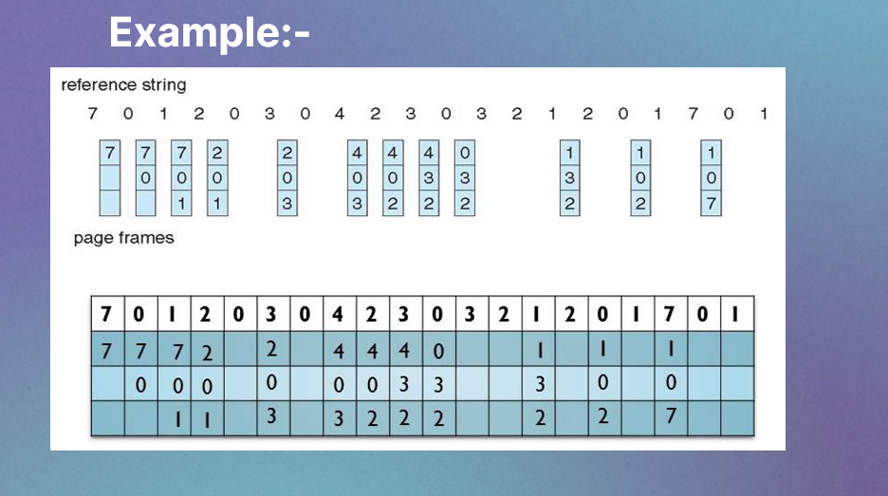

**VIII. Skills developed/ Learning outcomes**

- Derive: Derive different possible solutions creatively.

- Data Collection: Collect relevant data from different sources (books/the internet/the market/suppliers/experts and others through surveys/interviews)

- Designing- Designing microproject with minimum required resources and at low cost.

- Teamwork- Learning to work in team and boost individual confidence.

- Time management- Completion of microproject as scheduled.

- Technical writing- Preparing a report of proposed plan and report.

- Presentation and communication skills: Giving working model presentation of the micro project.

- Confidence: Confidently, answer the questions asked about the project.

- Efficiently gathering details from research papers.

- Writing an assembly language program using procedure

**IX. Applications of this microproject**

1. Educational Tools
2. Training and Workshops
3. Research and Development
4. Career Development
5. Linux System Administration
6. Open Source Contributions
7. Self-Learning and Practice
8. System Optimization
9. Operating System Research

**Micro Project Evaluation Sheet**

Name:Abdurrahman Qureshi Enrollment no: 2100020112

Name of programme: Computer Engg Semester: 5th

Course title: Opreating System Code: 22516

Title of microproject: LRU Replacement Algorithm

Course outcomes achieved:

i. Learned hot to do Software Analysis for the given topic.

ii. Learned how to do System Design for the given topic.

iii. Learned to code sysetematically for the given topic.

iv. Learned to do software testing fot the given code.

v. Learned to do Operation & Maintenance for the given code.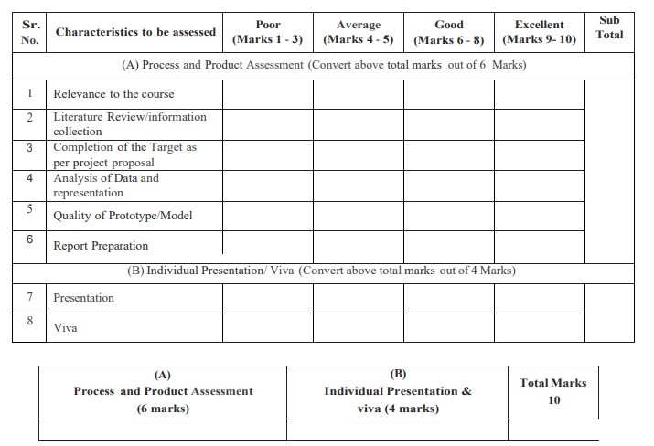

**Comments/Suggestions about teamwork/leadership/interpersonal communication ___________________________________________________________________________ ___________________________________________________________________________**

#### Name and designation of teacher: _____________________________________________ Dated signature: ______________________

**Micro Project Evaluation Sheet**

Name:Ansari Saad Enrollment no: 2100020102

Name of programme: Computer Engg Semester: 5th

Course title: Operating System Code: 22516

Title of microproject: LRU Replacement Algorithm

Course outcomes achieved:

i. Learned hot to do Software Analysis for the given topic.

ii. Learned how to do System Design for the given topic.

iii. Learned to code sysetematically for the given topic.

iv. Learned to do software testing fot the given code.

v. Learned to do Operation & Maintenance for the given code.

**Comments/Suggestions about teamwork/leadership/interpersonal communication ___________________________________________________________________________ ___________________________________________________________________________**

#### Name and designation of teacher: _____________________________________________ Dated signature: ______________________

**Micro Project Evaluation Sheet**

Name:Arya More Enrollment no: 2100020097

Name of programme: Computer Engg Semester: 5th

Course title: Operating System Code: 22516

Title of microproject: LRU Replacement Algorithm

Course outcomes achieved:

i. Learned hot to do Software Analysis for the given topic.

ii. Learned how to do System Design for the given topic.

iii. Learned to code sysetematically for the given topic.

iv. Learned to do software testing fot the given code.

v. Learned to do Operation & Maintenance for the given code.

**Comments/Suggestions about teamwork/leadership/interpersonal communication ___________________________________________________________________________ ___________________________________________________________________________**

#### Name and designation of teacher: _____________________________________________ Dated signature: ______________________

**Micro Project Evaluation Sheet**

Name:Adnan Kazi Enrollment no: 2100020117

Name of programme: Computer Engg Semester: 5th

Course title: Operating System Code: 22516

Title of microproject: LRU Replacement Algorithm

Course outcomes achieved:

i. Learned hot to do Software Analysis for the given topic.

ii. Learned how to do System Design for the given topic.

iii. Learned to code sysetematically for the given topic.

iv. Learned to do software testing fot the given code.

v. Learned to do Operation & Maintenance for the given code.

**Comments/Suggestions about teamwork/leadership/interpersonal communication ___________________________________________________________________________ ___________________________________________________________________________**

#### Name and designation of teacher: _____________________________________________ Dated signature: ______________________